PURCHASE PATTERN ANALYSIS – CDACL-005
INSIGHTS AND RECOMMENDATION:

Summary of the Raw Dataset:
- Type of Data: Retail transaction records (sales invoices).
- Key Columns:
  - BillNo: Invoice number (groups items per transaction).
  - Itemname: Product description.
  - Quantity: Number of units purchased.
  - Present_Date: Date and time of transaction.
  - Price: Unit price of the item.
  - CustomerID: Unique identifier for each customer.
  - Country: Customer’s country.
- Coverage:
  - Transactions span multiple countries (e.g., United Kingdom, France, Australia).
  - Includes both small retail purchases (e.g., 1–2 items) and bulk orders (e.g., 100+ items).
  - Products are mainly home décor, kitchenware, toys, seasonal items, and gifts.
- EXPLORATORY DATA ANALYSIS [EXCEL]:

Outlier Identification

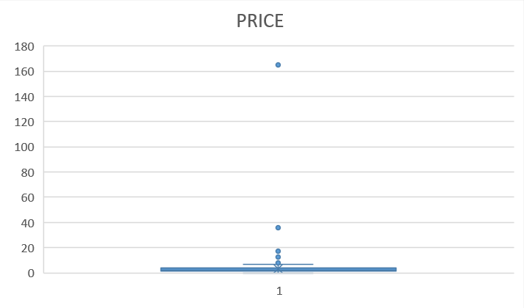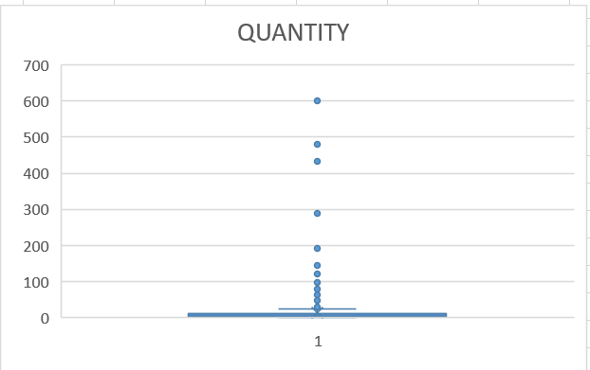

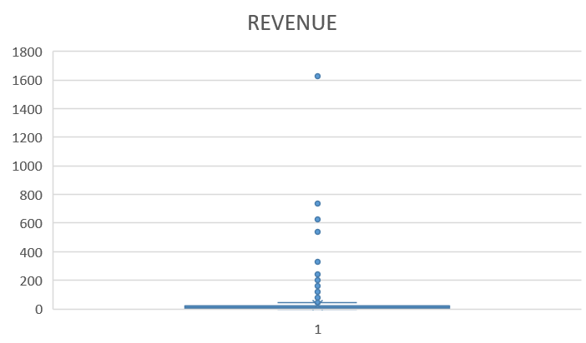
- Observed extreme values (e.g., Quantity max = 600, Price max = 165, Revenue max = 1627.2).

- High skewness and kurtosis confirmed heavy-tailed distributions with outliers.

Pivot tables:
- Country-wise Item Count: Rows = Country, Values = Count of Itemname.
- Country-wise Revenue: Rows = Country, Values = Sum of Revenue.
- Highlighted missing values and distribution patterns.

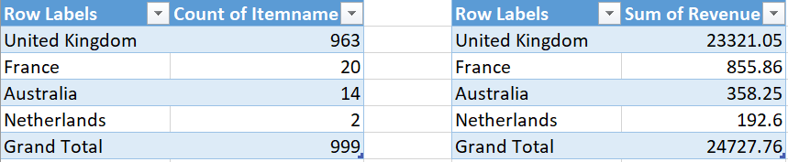

Quantity Distribution:
- Mean = 12.95, Median = 4 → Most orders are small quantities, but a few bulk orders inflate the average.
- Skewness = 9.25, Kurtosis = 109 → Highly skewed with extreme outliers (bulk purchases up to 600 units).

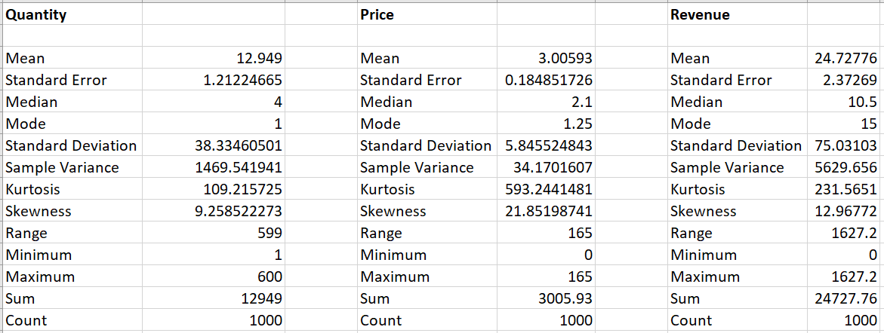
    - Price Distribution
- Mean = 3.00, Median = 2.1 → Prices cluster around low-value items.
- Max = 165 → Outliers exist (likely large or premium items).
- Skewness = 21.85, Kurtosis = 593 → Very heavy-tailed distribution, dominated by small inexpensive items with rare high-value products.
    - Revenue Distribution
- Mean = 24.7, Median = 10.5 → Most transactions are modest, but bulk orders push the average up.
- Max = 1627.2 → Large wholesale invoices.
- Skewness = 12.96, Kurtosis = 231 → Revenue is highly skewed, showing dependence on a few big customers.
    - Country-Level Analysis
- United Kingdom dominates:
- 963 transactions (≈96% of total).
- Revenue = 23,321.05 (≈94% of total).
- France, Australia, Netherlands contribute marginally.

InsightS:
- The dataset is UK-centric, with other countries being niche markets.
- Sales are dominated by small retail items, but bulk orders create extreme outliers.
- UK is the primary market, accounting for nearly all revenue.
- Outliers (bulk orders, premium items) heavily influence averages — median values are more representative of typical sales.
- Segmentation needed: Separate analysis for bulk vs regular customers to avoid distortion.

- Occurence Analysis

Insights:

Regular customers repeatedly purchase hand warmers (Scotty Dog – 194, Union Jack – 178, Bird – 148, Owl – 147).

Decorative items like WHITE HANGING HEART T-LIGHT HOLDER (141) and ASSORTED COLOUR BIRD ORNAMENT (136) show strong recurrence.

Seasonal items (PAPER CHAIN KIT 50’s CHRISTMAS, HOMEMADE JAM SCENTED CANDLES) highlight festive demand. ➡️ Occurrence analysis reveals core retail drivers: small, affordable, gift-like items dominate regular purchases.
- Trend Analysis

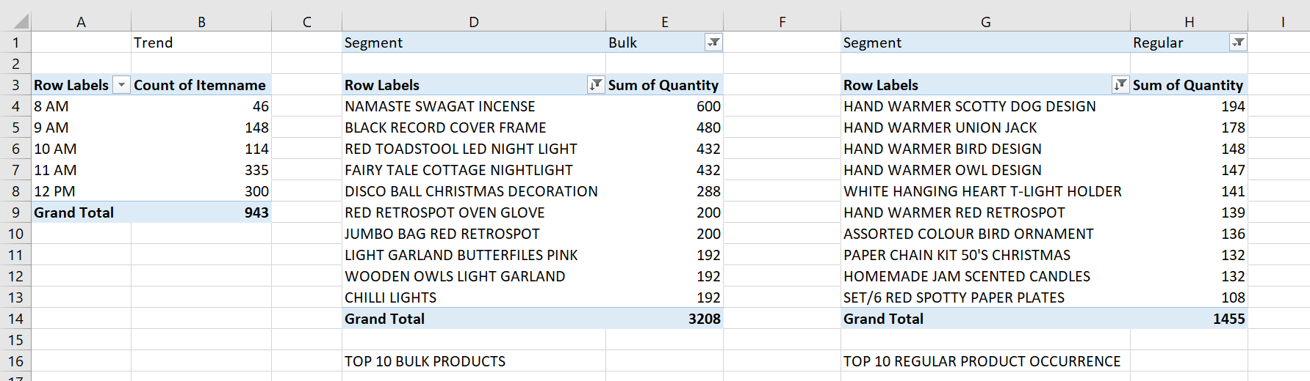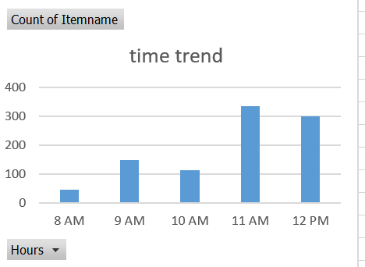

Visualization:

Bar chart showing item counts by hour.

Insights:

Peak hours: 11 AM (335 items) and 12 PM (300 items).

Midday surge: Most transactions cluster between 10 AM–12 PM. ➡️ Trend analysis shows time-sensitive shopping behavior — midday is the optimal window for promotions and campaigns.

- Segmentation Analysis

Comparison:

Top 10 products in Bulk vs Regular segments.

Highlight differences in product categories and purchase volumes.

Insights:

Bulk Segment:

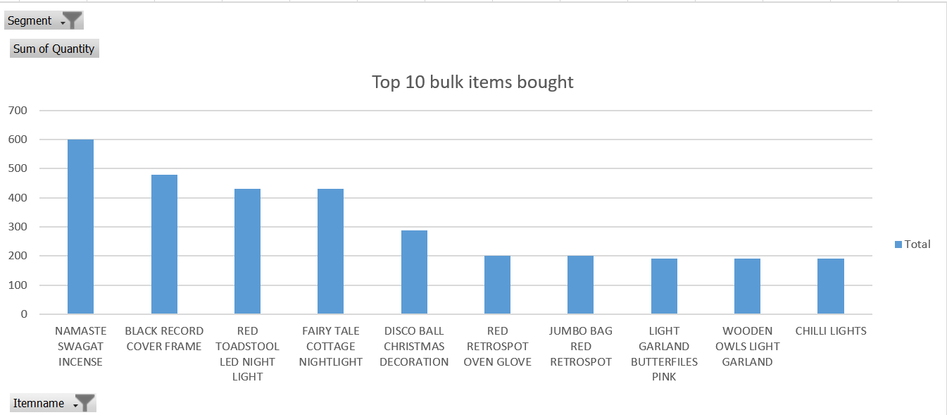

Dominated by wholesale items: NAMASTE SWAGAT INCENSE (600), BLACK RECORD COVER FRAME (480), RED TOADSTOOL LED NIGHT LIGHT (432).

Decorative lighting and seasonal stock drive bulk orders.

Regular Segment:

Focused on personal-use items: hand warmers, ornaments, candles, and small decor.

Purchases are smaller in volume but more diverse. Segmentation analysis shows two-tier demand: bulk buyers prefer large decorative/utility items, while regular customers lean toward small, gift-oriented products.

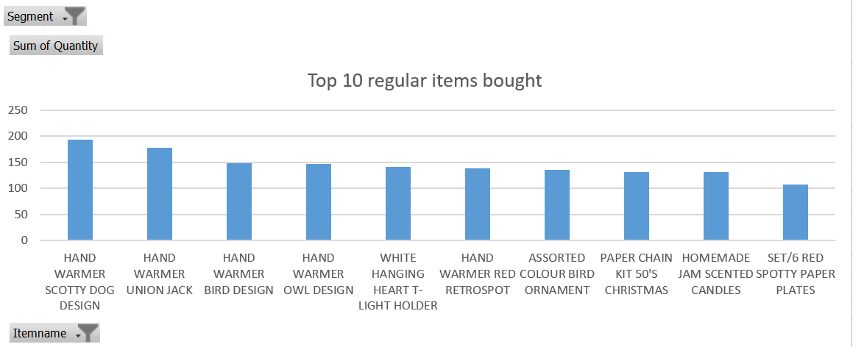

- DATA PREPARATION FOR IMPLEMENTATION OF ALGORITHM:

Built two pivot tables:
- Bulk Segment: Top 10 products by summed quantities.
- Regular Segment: Top 10 products by summed quantities.

Pivot as Matrix (Cross-tabulation)

Converted each pivot into a matrix format:
- Rows → Product names.
- Columns → Quantities or occurrence counts.
- Values → Summed totals.
- This step ensured the data was structured in a tabular matrix form suitable for Orange workflows (association rules, clustering, etc.).
- Cleaned headers (e.g., Product, Quantity) for consistency.

Export to Separate Files
- Saved each matrix pivot as a CSV file:
- bulk_products.csv
- regular_products.csv.
- Ensured static values (Paste Values) so Orange could read them without pivot dependencies.

- ASSOCIATION ANALYSIS:

APIORI ALGORITHM FOR PATTERN USING ORANGE:

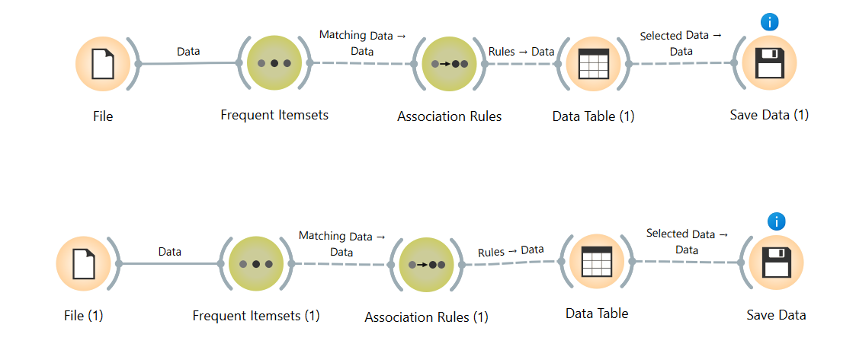

insights:

Bulk Segment: Rules highlighted strong co-occurrence among wholesale decorative items (e.g., incense + lighting).

Regular Segment: Rules revealed associations among small gift items (e.g., hand warmers + candles).

Strategic Value:

Bulk rules help optimize inventory bundling for wholesale customers.

Regular rules guide cross-selling and recommendation systems for retail buyers.

- RULE SELECTIONS AND INSIGHTS:

Rule Selection
- Filtered to the Top 50 rules/patterns based on Lift.
- These represent the most meaningful associations for reporting and visualization.

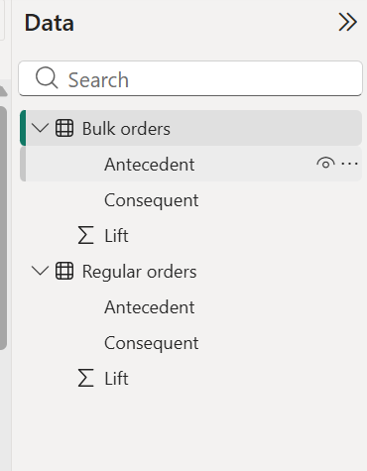

Insights:
- Focus on Lift: By grouping and ranking rules by Lift, highlighted the associations that are statistically strongest
- Top 50 Patterns: This selection balances comprehensiveness with clarity, enough rules to show variety, but not so many that reporting becomes cluttered.

Strategic Value:
- Bulk segment → strongest wholesale bundles.
- Regular segment → strongest cross-sell opportunities.

- DATA VISUALIZATION [Gephi (alt for powerbi viz)]:

Visualization (Gephi Network Graph):

BULK:
- After cleaning and transforming the association rules in Power BI, the top 50 patterns were exported into Gephi.

Gephi was used to build a network graph, where:
- Nodes represent products.
- Edges (lines) represent association rules between products.
- Edge thickness reflects the strength of the relationship (Lift).
- Clusters emerge naturally, showing groups of products that frequently co-occur.

Insights from the bulk item graph:

Clusters of Related Products:

Decorative items like FAIRY TALE COTTAGE NIGHTLIGHT, LIGHT GARLAND BUTTERFLIES PINK, and CHRISTMAS GINGHAM STAR form a strong cluster — indicating they are often purchased together.

Seasonal items (DISCO BALL CHRISTMAS DECORATION, POLKADOT RAIN HAT) connect into festive bundles.

Central Nodes:

Items such as BLACK RECORD COVER FRAME and JUMBO BAG RED RETROSPOT appear as hubs, linking to multiple other products.

These hubs represent cross-selling opportunities — products that bridge different customer segments.

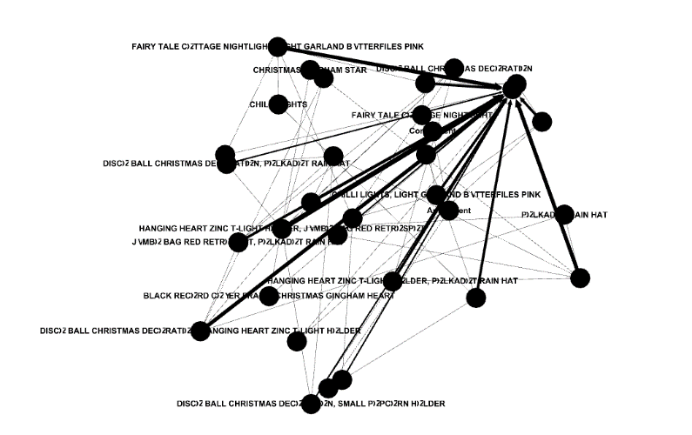

REGULAR:

Visualization (Directed Graph in Gephi)
- The association rules exported from Power BI were visualized in Gephi as a directed network graph.
- Nodes represent products, while edges (arrows) represent the direction of association (antecedent → consequent).
- Edge thickness reflects the strength of the relationship (Lift).
- Special nodes like SOURCE and Confluent act as anchors, showing how rules flow or converge.

Insights:

Strong Product Pairings:

Items such as WHITE HANGING HEART T-LIGHT HOLDER and WOODEN FRAME ANTIQUE WHITE are tightly connected, indicating they frequently co-occur in transactions.

Similar strong ties exist between CREAM CUPID HEARTS COAT HANGER and WOODEN FRAME ANTIQUE WHITE, showing bundles around decorative home items.

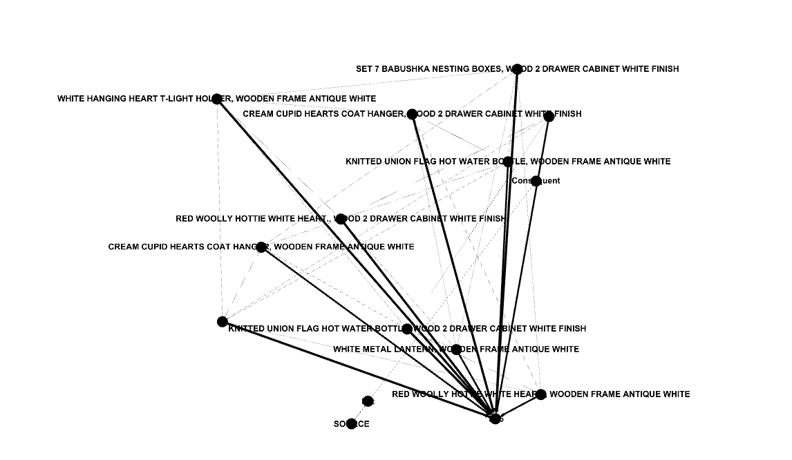

Clusters of Related Products:

Decorative and gift items (lanterns, coat hangers, hot water bottles) form dense clusters, suggesting natural product groupings for cross-selling.

Seasonal items like RED WOOLLY HOTTIE WHITE HEART and KNITTED UNION FLAG HOT WATER BOTTLE connect into a winter/holiday cluster.

Directional Flow:

The directed edges show which products lead to others in association rules. For example, buying a SET 7 BABUSHKA NESTING BOXES often leads to a WOOD 2 DRAWER CABINET WHITE FINISH.

This directional insight is valuable for recommendation systems — suggesting the next likely product.

Anchor Nodes:

SOURCE and Confluent nodes highlight convergence points, where multiple rules overlap.

These act as hubs in the network, showing products that connect across different clusters and can serve as gateway items in marketing.

- OVERALL ACTIONABLE INSIGHTS:

Product Occurrence
- Hand warmers, candles, and small décor items dominate regular purchases.
- These are repeat drivers of retail sales and should be kept in steady stock.
- Action: Bundle hand warmers with complementary winter items (e.g., hot water bottles) to increase basket size.

Time Trend
- Midday (11 AM–12 PM) is the peak sales window.
- Action: Schedule promotions, flash sales, and targeted ads during this slot to maximize conversion.

Segmentation
- Bulk buyers prefer high-volume decorative/utility items (incense, lighting, frames).
- Regular buyers focus on small, affordable, gift-like items.

Action:
- Maintain two-tier inventory strategy: large stock for wholesale, diverse small items for retail.
- Design separate marketing campaigns: wholesale bundles vs. retail gift packs.

Country Distribution
- United Kingdom accounts for ~96% of transactions and revenue.
- France, Australia, Netherlands are niche contributors.
- Action: Prioritize UK for inventory and marketing, while testing seasonal promotions in smaller regions.

Association Rules (Orange → Power BI)

Top 50 rules ranked by Lift reveal strong co-purchase patterns.

Action:
- Use high-lift rules to design cross-sell recommendations (e.g., lanterns + frames, hand warmers + candles).
- Deploy these rules in e-commerce recommendation engines or POS systems.

Network Graphs (Gephi)
- Clusters show natural bundles (e.g., decorative lighting + seasonal ornaments).
- Hubs like WHITE HANGING HEART T-LIGHT HOLDER and WOODEN FRAME ANTIQUE WHITE act as anchor products.

Action:
- Promote anchor products as entry points, then cross-sell connected items.
- Build bundle offers around clusters to increase average order value.

- Strategic Takeaways

🔹 Inventory & Product Strategy
- Anchor Products: Keep WHITE HANGING HEART T-LIGHT HOLDER, WOODEN FRAME ANTIQUE WHITE, and JUMBO BAG RED RETROSPOT in high stock — they act as hubs in the network and drive cross-sales.
- Bundle Creation: Package decorative items (lanterns, frames, coat hangers) into themed bundles (e.g., “Home Décor Essentials”) to leverage strong associations.
- Seasonal Stocking: Increase inventory of hand warmers, candles, and Christmas décor before winter and holiday seasons — these items cluster strongly in rules and graphs.

Marketing & Promotions
- Time-Based Campaigns: Target 11 AM–12 PM with flash sales and push notifications — this is the peak buying window.
- Cross-Sell Recommendations: Use high-lift rules to suggest add-ons (e.g., “Customers who bought a lantern also bought a frame”).

Segmented Campaigns:
- Bulk buyers: Offer wholesale discounts on incense, lighting, and frames.
- Regular buyers: Promote gift packs of hand warmers, candles, and ornaments.

Regional Focus
- United Kingdom Priority: With ~96% of revenue, UK should remain the primary market.
- Niche Expansion: Test small-scale seasonal promotions in France, Australia, and Netherlands to gauge demand before scaling.

- Strategic Recommendations
- Maintain dual inventory strategy: bulk stock for wholesale, diverse small items for retail.
- Leverage association rules for cross-sell and bundle offers.
- Prioritize UK campaigns, while experimenting in niche regions.
- Time promotions around midday peaks to maximize conversions.
- Deploy recommendation systems using top rules and network hubs for personalize.

TOP 10 REGULAR ITEMS OFFERS:

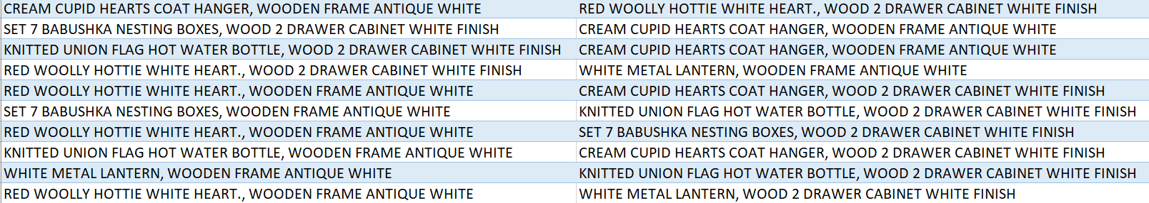\

TOP 10 BULK ITEMS OFFERS:

